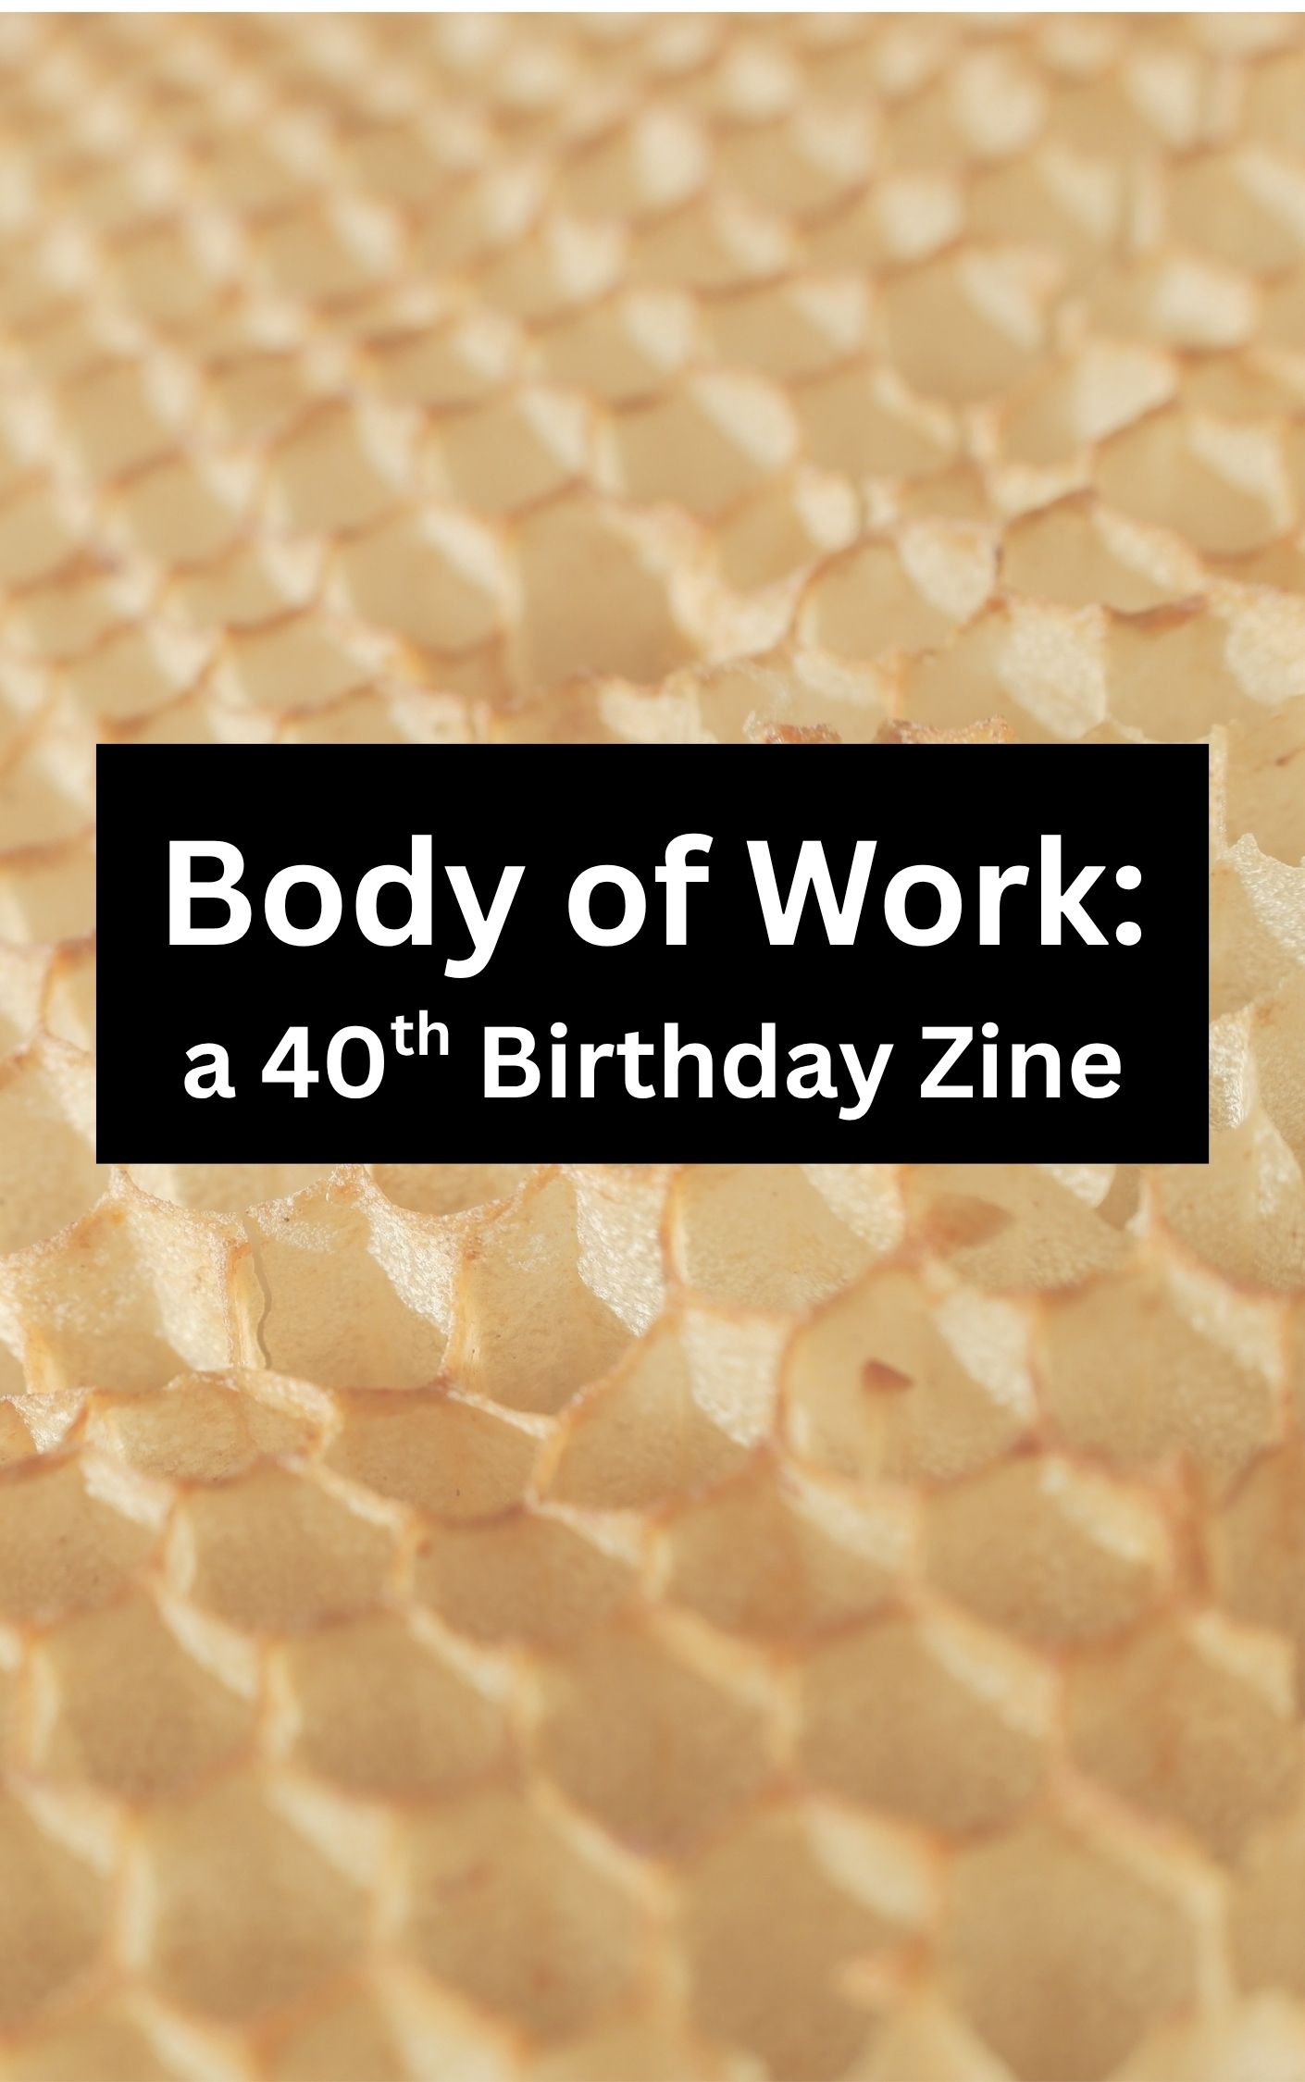
Introduction to this Birthday Zine
Hello world, I am 40!
Let me start by saying: I think this is excellent news, and I am happy to be celebrating.
I have been obsessed with the printed word for longer than I have memories. Books and newspapers felt so good in my hands, and I wanted to make my own.
So I did.
And when I take stock of my life so far, it makes the most sense to measure forty years in the things I have self-published, or small-world-published. Because that’s been one of the most consistent themes.
- Starting in fifth grade, I made a newsletter about the games and ideas and interests of all the kids who lived on my street. With a word processor. I stuck it in people’s mailboxes.
- I got in trouble for making a zine at the end of high school. The story mostly makes me look bad. I am proudest of a physical cut-and-paste cover I made, with Sharpie markers and letters cut from magazines with an X-acto knife.
- Blogging about my life began in 2004; I'm of the Livejournal generation. Xanga. Deadjournal. Blogger. Wordpress. I’ve done them all.
- Senior year of college, I was paid $16 per week to copyedit the entertainment section of the Marquette Tribune. My friend was the editor, and he assigned me writing for every edition. More than once I wrote the cover story.
- I’ve been published in literary journals via universities or cool groups of people since 2009.
- Over my 12-year youth development career, I taught zine-making to kids in both New Brunswick and Lakewood, NJ.
- When I moved to South Jersey in 2019, I made a fan zine for Barbara Kingsolver’s novel, Unsheltered, because it is set in Vineland. I mailed her a copy and she wrote me a sweet note back how awesome South Jersey is.
- I sold two prose chapbooks to literary presses, in 2021 and 2022. The first was a collection of flash fiction using classic horror tropes to tell stories about bad modern relationships. The second was an essay about learning to read tarot.
- The summer I turned 37, my partner gifted me a nostalgic-looking Fuji Instax camera. I used pictures printed on film, scissors, and hot glue to make collaged shadowboxes for my two brothers, after we traveled to Japan, as well as for my sister and her bridal party, for my sister's wedding. The spirit of zines moved through me for these.
- The autumn that I was pregnant, I contributed to a horror zine. My story is about a woman who won't take her husband's last name. She rips up the sod in their suburban house and plants a wild clover lawn. Her neighbors hate this. One night under the full moon, a cradle appears on top of the clover, with her baby in it. The baby is a monster who rips out the tongues of her gossipy older neighbors in the night. A total fabrication!
- I was pregnant and had a baby. Then I got sick and needed surgery. For these reasons, plus the passing of time, the only body I will ever inhabit feels different. This is a topic that fascinates me. I write about bodies a lot.
- While I was giving birth on New Year’s Eve, I had a flash fiction piece go live. I wrote flash fiction again when my baby was six weeks old. And saw some little pieces I wrote when I was pregnant become published when my little one was in the world.
- I was going to make a joke, like, Asa is my best output ever! But Asa is a person and gets to make a narrative out of life. And yet! I feel love for this kid in every part of me, physically and metaphysically. There will be Asa-DNA in my body for as long as it exists.
And then there’s this zine. IT IS SO FUN TO READ THE WORK OF MY FRIENDS. And put it out into the world, with paper and ink.
Thank you for writing, and reading, and being in my life.
With gratitude,
Laura Eppinger, July 2026

Self-Portrait in a Lost Ship
When I was a kid
I got sick a lot.

My mother would scrip
antibiotic or decongestant.

The pharmacist filled it
though she was only a nurse

because, he said,
"your mother is smarter

than any doctor"
—and that's fair,

but her father—remember,
it's the Forties in Brooklyn—

wouldn't pay for school
because she was a girl.

Later she published a story
in a magazine.

Her teacher stole it
though she was

not good enough
to be

a writer because

she was
only
a girl.

She painted a caravel
just before I was born
cutting through dark waves
though the sky was blue.
It is my ship
I am the ship
I am that ship
it is my ship.
Some random assassin
observed that the sails
were blown forward against
the direction of the waves
so the scene was "physically
impossible and fatally flawed."
My mother drove a knife
across that world
hid the canvas in a closet
and never opened.

It is my ship
I am that ship.

Not enough to be
a doctor, writer, painter

she tore a shape for her
final child: a caravel

of sails in a wind fighting
waves under a blue sky—

It is my knife.
I am her knife.
By: Anthony Lioi

Conductor
for 陳 指挥

When the letters leave
and there is nothing left
but quiet absence,
but crashing desolation,
I can no longer ask
When can I come back to myself?

Once the call is made
and there is no more
to distract,
to push off,
to let be for now,
I
make a choice, even
if I decide nothing,
once the time comes due.

Since I could shrink
and say none of it mattered,
anyway.
This is, of course, what
would happen all along.
Since I could say
this was nothing
that I felt nothing.
All wrong.

But I hold
your tiny brush
in my hand
and see you watch
my every move.
And I hear you
ask, with words you
don’t have yet,

“What were you
before you were
my everything?
Before everything
you were made to bear?”

So I answer
“Now that you’re here,
I was never meant to do this
alone.”

By: E.B. Chen

Ruach of Lisa
When my mom died, everything shrank. It seemed like the lungs of my life exhaled their oxygen; what was left was only the postage stamp from that old postcard of my world before.
She was a tiny 89 pounds. Scleroderma had hardened her organs, contracted her left hand into unusability – leaving her a slight version of the once muscular, athletic woman that oozed with a devil-may-care vitality. My sisters said the undertaker, a man-boy in a suit much too large for him (I picture David Byrne in Stop Making Sense) carried her over his shoulder like a child.
She looked so pretty that last year of her life, like the waning, crescent version of a moon once-full.
Her presence in my life was also a slight version of the once larger-than-life space that she had so long occupied. She had become a gentle comfort, a refreshing breeze. A hard-won breeze – for both of us, I might add. We each crossed oceans of flames to forge a new way. I think we somehow understood that about each other, without those words ever needing to be spoken. One of the last texts I sent her was, “Just finished Arundhati Roy’s Mother Mary Comes to Me. It says everything about all the grief and joy between a mother and a daughter.” She never wrote back to that; she didn’t need to.
I gifted each of my sisters that book for Mothers Day this year.
I didn’t sleep the night my mom died. My daughter came to get me in the middle of the night. She knew. Lying next to her, I realized that she had also been inside my mom – as an ovum inside of my fetal self. I felt my mom’s spirit wash over us.
When I picked my daughter up from school that next day, one of her classmate’s moms offered her condolences. I know this woman very well; our daughters have been best friends for five years. I just didn’t have the energy to engage. Those lungs of my life had exhaled already. The woman was telling me about grief and about taking time and all the nice things one says to someone else when they’ve lost something. Inside my head it was black and fuzzy. I said to her, “I’m so sorry, but I’m so tired. I just need to sit down.” I went and sat on a bench alone when our children continued to play on the playground.
This exhale and all that it breathes out has been disorienting. I expected sadness and longing, but I did not expect this, this somekindof wilderness. Our arc is so much more than the last bend in our bow. I am reminded that I started as an ovum nestled inside my fetal mother, that we were braided together through and across so many earthly thresholds. With her loss from this world, my original tether is gone. I feel it like a limb.
By: Sarah Cunningham

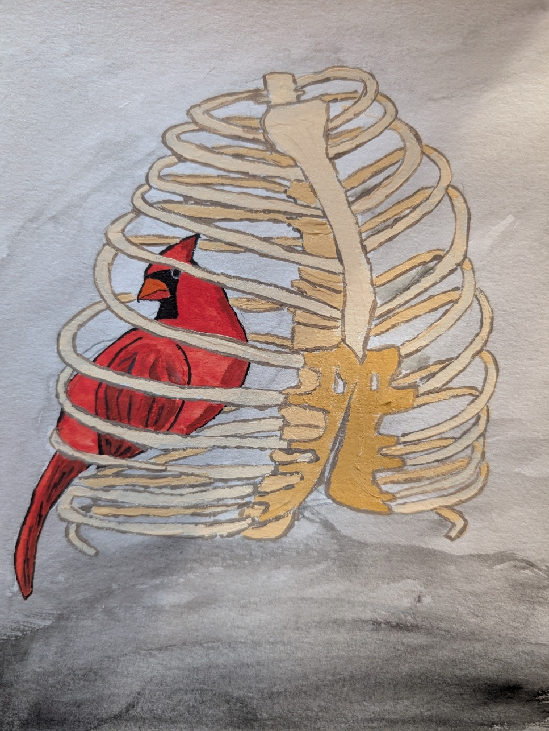
By: Ali Schaefer
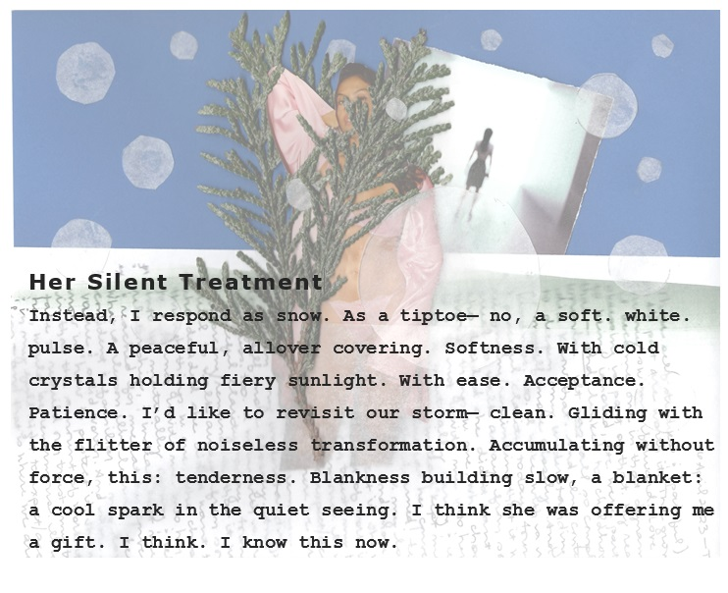
By: Nicole Miyashiro

My body, I love her
My soul picked her as home
Great tits, symmetric face
I love this place

The brain is a little zany
Complicated and brave
Her pussy, a portal
It’s too bad, for every beautiful thing is mortal
My belly keeps its secrets,
A map of where I've been.
A little bit of chaos,
A little bit of sin.
My hips are not just curves,
They're architecture and art.
They carried life and laughter,
And still can steal a heart.
My thighs are loyal soldiers,
They've carried me this far.
They climb, they dance, they conquer,
They know exactly who they are.
My body is a contradiction,
A goddess and a clown.
She can birth a little miracle,
Then trip while walking down.
My body, I love her

By: Melanie DiBenedetto
My Body is Movement
I am a wobbly being. I was made with collagen that is just a bit faulty I am told, but that is difficult to see and even more difficult to diagnose correctly. So instead, what you can see is that I am a shimmying goddess who sometimes stretches slightly farther than joints were made to go. This results in an absolutely overwhelming awareness of so many things, you can just imagine; the skin, the insides, the outsides, the eyeballs, everything. I am typically always in the low hum of pain. Sort of like that character from Peanuts, Pigpen who wanders around wafting dirt everywhere.
There is a ride at Disneyworld known as the “Flight of Passage.” There is nothing particularly nifty about the ride thematics, except that it’s based after some one or other movie that vaguely critiques colonization, but doesn’t really—because the colonized can, of course, become the indigenous, but better. I digress though. The magical thing about this ride is that the seat they put you in supports your body on all sides, including your back, your legs, your hips, and your hands. You are tucked in to a small exosuit that breathes underneath you (you know, to simulate the native creatures of Pandora or Pangea or whatever the planet was called). The important part of this ride for me, and what makes it my absolute favorite, is that while strapped into this contraption which acts as my own micro-gravitational support field, I feel entirely and utterly free. I rode it three times in one day, which for the popularity of that ride, is an insane number of times. If I had known she existed, I would’ve labeled myself a very happy Violet Sorrengail.
Recently, I experienced a similar, if more muted joy, the feeling of a speed boat skipping over the waves as I set myself, held on, and stood while we hopped over every wave. This also was a form of freedom, a form of fleeing from the constant and continual knowledge that my body is one built on chronic pain, an inability to be held still, and the daily and hourly management of eruptions of movement and disability. The muscles and joints often go in opposite directions, neither quite sure of what their responsibilities are to the possibility of forward, sideways, or backwards motion. As such, my Fitbit always reads me as having spent as many calories as a workout from merely sitting on the couch and making a bold attempt at becoming vegetation.
Philosopher, activist, and cultural critic Alexis Pauline Gumbs in her meditation, Undrowned, considers loving the self and the non-human animals and flora with which we share the world. In it, she asks her readers to practice small moments of being in touch with their hair, their body, the world around them. I write an ode then to a body and a mind which never stops moving and is constantly in a state of hyper proprioception and interoception. Find the moments, dear carnal entity, where you feel entirely supported and can fly into the sky, free as a bird, but constrained in all excess. That tension which your collagen lacks can set a world in time and space, but never in stillness.
By: Kris McLain
Chief DNA Evidence

Courageous, endearing, inspiring little pup
He gave his life to protect his owners
In doing so, his blood was the key to finding their killer
Fur ever a cherished friend in Chief

By: Megan Andreuzzi
Glass Kept Full
I won’t tell them
but as they talked the words
started to pour like pinot grigio
see through it as it splashes
against my empty glass
cause one sip
turned to a gulp
and it’s been minutes
since my last purse of lips
I tried to check my face
but my tongue was sour
from the last bit of saliva
still feeling green like grapes
that had to mash
beaten to a pulp
so I could swirl a cup
and find the right way
to be glass full
keep it frosted and fingers numb
from pinching stems
the right way, you’ll say
since you need something to say
and I won’t say I want another
until I’ve spilt all over their place

By: A.N. Delis

Untitled
I choke on the thought of greatness
like the first gulp of cherry cough
medicine mom made me drink
It doesn’t get easier to swallow
tapping on plastic drums, bottoms up!
last drops splashing up on buck teeth
It doesn’t settle any better
when it falls face flat on stomach acid
learning why it’s a belly flop
and not a belly dive
to the bottom I go,
scanning for torpedoes
lungs mock
can she do it?
the water slips into lenses
as if dripping to track seconds
I know it’s there
I go three blind mice til I find it
trying not to let the thought rush back up
begging for air
drown it if you must
feel the power of fingertips
gasping for it
wrapped in knuckles
I almost strangle it

By: A.N. Delis

My Hands

When I was young, my hands
reached to other hands for help;
soon I learned how to pull myself up.
My hands mastered grasping
a pencil, writing messily
and beautifully, simultaneously.
My hands learned to knead
dough and massage memory
from forehead. My hands
brushed hair from my eyes
so I could see better;
felt around the dark,
putting themselves in danger
first. Hands dealt with my nail biting
habit. These hands held rackets
and books and Trident gum packets.
My hands have held space for
hellogoodbyes and long embraces;
but have never held my tongue.
My hands have extended my voice
to pages before me. My hands
have spoken louder before I knew how.
My fingers have let texture linger,
distinguished hair raised from fear
and anger. My hands have
braved gloveless winter nights
and suffered papercuts from cardboard
hearts for those I loved. My hands
knew the distance from lover's
eyes to lips, the exact coordinates
to meet skin to skin before a kiss.
My hands have wandered into unknown
territory, hesitantly and hurriedly.
My hands have been dirty and
baptismally clean. They have stroked
blades of grass and hair; wiped
tears without judgment and
somehow still saved face.
My hands shielded me.
My hands have said grace.
My hands have raised cups
and flags. I swear I've seen them
raise the dead, propping up
tomato plants in a garden bed.
The best thing my hands have
ever done were
hold another
hand.

By: Julie Hmieleski

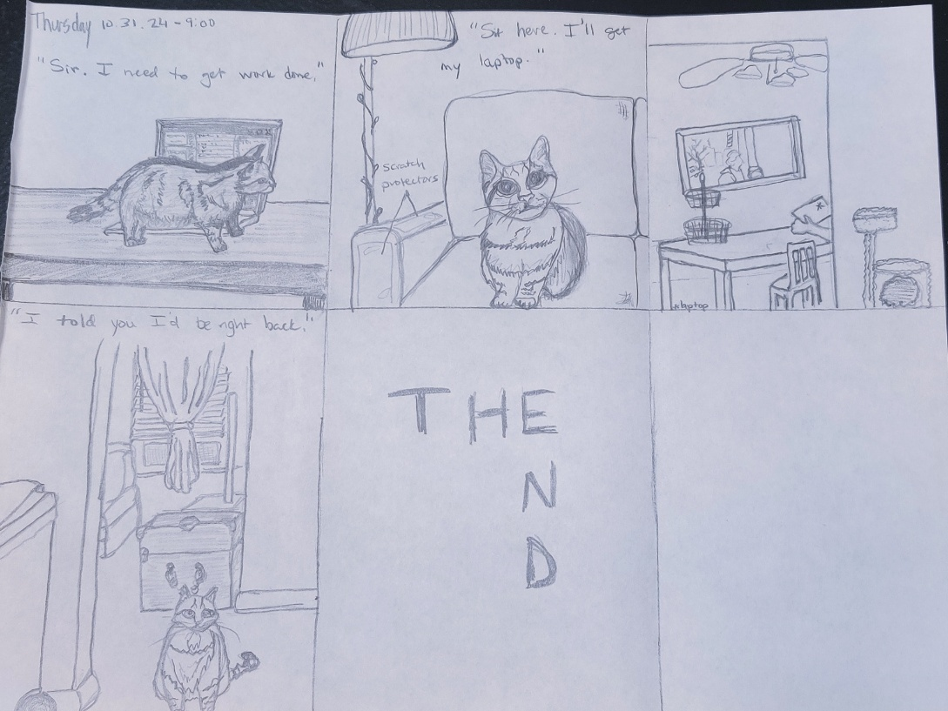
By: Erin Yerke

Laura Eppinger turns 40!

A zine with work by:

Anthony Lioi
E.B. Chen
Sarah Cunningham
Ali Schaefer
Nicole Miyashiro
Melanie DiBenedetto
Kris McLain
Megan Andreuzzi
A.N. Delis
Julie Hmieleski
Erin Yerke

Laura was inspired to make this zine with influences from: Kathy Acker, Chris Kraus, the Slingshot collective and annual publications, reading books from PM Press and cooking every recipe from “Licking the Beaters: Low-Fat Vegan Desserts” Volumes 1&2 by Siue Moffat. Laura learns about new zines from Erin Dorney’s newsletter, which you can learn more about here: https://www.erindorney.com/

